Azyurmardi Azra

State Islamic University, Jakarta, Indonesia

Mercredi 16 novembre - 14 heures, salle H 202

Campus Porte des Alpes

Islamic Studies Paradigms: Indonesian, Western, and Middle Eastern Compared

Abstract: "The presentation deals with the Islamic studies, particularly at tertiary level. It is argued that some distinction of Indonesia Islamic studies is different from the ones developed in Western countries and the Middle. The distinctions of Indonesian Islamic studies, it will be suggested, have a lot to do with the distinctive nature of Indonesian Islam as well as with the understanding and practice of Wasatiyah Islam among Indonesian Muslims. For that purpose, the presentation will give an outline of development and dynamics of Indonesian Islamic Higher Education from the beginning to the present time".

Débat animé par

Christine Chojnacki, Professeur de langues et cultures indiennes, Faculté des langues, Université de Lyon 3

Marina Rougeon, Post-doctorante en anthropologie, LabEx COMOD – ENS, Institut Supérieur d’Etude des Religions et de la Laïcité

 ../Downloads/univ-lyon3-vecto.pdf 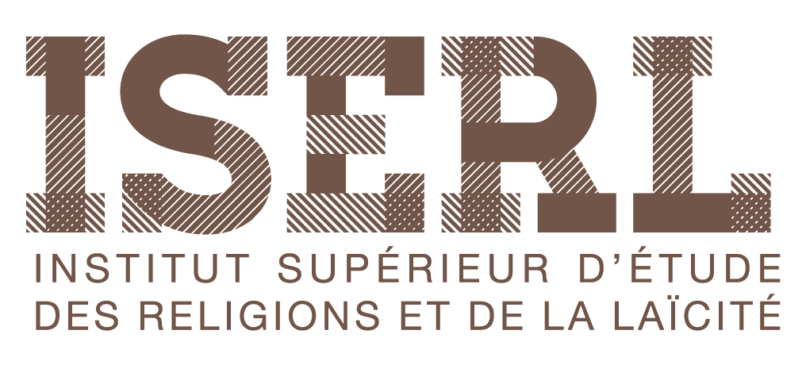 Film%20Capt'eye%20Palse/logos/Logo_UMR_source_2016.pdf